Flex Online Course Development Process

Overview
Course development follows a pedagogically intentional process whereby program directors, subject matter experts, and the Mays Teaching & Learning Innovation Team collaborate to design, develop, and deliver Flex Online courses in the Texas A&M University and Mays digital learning environment. The Learning Design, Learning Media, Learning Quality, and Learning Delivery groups make up the Mays Teaching & Learning Innovation Team.
This guide provides details about:
- Roles & Responsibilities of Those Involved in Course Development Projects
- The Flex Online Course Development Process
- Supporting Resources

Roles & Responsibilities
Throughout the Flex Online course development process, you will interact with a course development project team; the project team is made up of a Program Director, Subject Matter Expert (you), Instructional Designer, Portfolio Manager, and the Directors of Learning Design, Learning Media, Learning Quality, and Learning Delivery, as well as the Executive Director. Each role plays an integral part in the successful completion of a Flex Online course development project. When assigned to design and develop a Flex Online course, you will receive a Course Development Agreement, which provides more in-depth information about each role.

Program Director (PD)
The PD is the person designated by the department and/or the Deans to oversee the Flex Online Program and partners with the Mays Teaching & Learning Innovation Team for the planning and success of a course development project. In collaboration with the Director of Learning Design (DLD), the P Dr engages in program planning and continuous improvement efforts, identifies and coordinates faculty to develop courses, conveys Subject Matter Expert (SME) expectations, gathers and tracts relevant program data and materials, and manages project challenges and/or barriers. In addition, the PD may serve as a liaison to the enforcement of required course associate role training and other program and course-related decisions and logistics.

Subject Matter Expert (SME)
The SME is a faculty member assigned to partner with an Instructional Designer (ID) to develop the content of a Flex Online course. As the content expert, the SME curates and develops learning materials, activities, and assessments that align with program, course, and module-level learning objectives and promote active learning. While the SME develops the content, the ID applies a pedagogical lens to what is developed, thereby providing feedback, applying edits, reviewing content for accessibility and copyright compliance, and building the course in a Canvas Development Course. After the course is taught, the SME collaborates with the project team to analyze student feedback and course analytics and then develop a course maintenance plan to address the data gathered.

Instructional Designer (ID)
The role of the ID is to partner with the SME to plan and develop a pedagogically sound pathway to course design with the adult learner in mind. The ID is a skilled professional trained to employ collaboration, communication, project management, and targeted technical skills to design meaningful and engaging instructional content. The ID and SME meet frequently to discuss ideas for developing applied and interactive assessments and learning activities. In addition, the ID coordinates with the Learning Media Team to design and develop course media elements. Throughout the course development process, the ID applies course design best practices to include Adult Learning Theory, accessibility standards, Backward Design, and Universal Design for Learning principles. While the SME develops the various elements of the course, the ID provides feedback, edits, and builds and tests course content, tools, and learning technologies in the Mays Digital Learning Environment. After the course is taught, the ID collaborates with the project team to analyze student feedback and course analytics and then develops a course maintenance plan to address the data gathered.

Portfolio Manager (PM)
The PM is an ID assigned to direct and manage a portfolio of course development projects within a program. The PM serves as the point of contact for instructional designers working on courses within the portfolio and monitors progress of each course development project; as needed, the PM collaborates with the project team to recalibrate the timelines of projects according to the project health escalation process. The PM provides guidance to IDs on the development of content to ensure program-level objectives are addressed and provides input to the design and development of program-level media assets. The PM collaborates with the project team to develop the course maintenance plan.

TLI Leadership
The Teaching & Learning Innovation Team leadership assists in managing the workflow throughout the phases of course development and provides strategic and operational oversight.

Executive Director (ED)
The ED collaborates with the PD to operationalize the Flex Online Program by coordinating program and course development logistics, such as engaging in program planning, identifying course sequencing, and providing faculty orientation to the Flex Online course development process. The ED also provides oversight of the course development lifecycle across the TLI unit and collaborates to troubleshoot challenges to course design and delivery.

Director of Learning Design (DLD)
The DLD collaborates with the ED and PD to plan the Flex Online Program, which includes identifying program-level objectives, course sequencing, course topics, and assignment and multimedia ideas across the program. The DLD provides oversight of all course design and development projects, assigns PMs and IDs to execute and manage the workflow of projects, works with the project team to recalibrate timelines as needed, reports project status to TLI leadership, and leads the development of the course maintenance plan across the program.

Director of Learning Media (DLM)
The DLM collaborates with the ED and PD to plan the Flex Online Program-level assets, such as the video intro and outro color palette and images, and images and icons to be used throughout courses in the program. The DLM also collaborates with the DLD, ID, and SME during the media planning phase of course development. During this phase, the DLM provides guidance and oversight of the media plan, which includes the preproduction, production, and post-production of all media assets for the course. Media assets that may be created include short demonstration or lecture videos, podcasts, and infographics, to name a few.

Director of Learning Quality (DLQ)
The DLQ provides feedback to the ID and SME throughout the course development process through a thorough review of course alignment and organization, cognitive load, learner engagement and experience, and accessibility of materials. A peer review is conducted of the course map and all course materials after the course content creation phase of development. During this phase, the Learning Quality team may provide recommendations for improvement of course content, prior to building the course. A technical review is then conducted after the course build phase of development to verify course settings, assignment due dates, accessibility of materials in Canvas, and the validation of all course links.

Director of Learning Delivery (DLDV)
The DLDV collaborates with the ID, SME, and PM to plan and prepare for the delivery and production of weekly cohort sessions. Cohort sessions are 90-minute synchronous class sessions facilitated by the instructor/SME in a Virtual Learning Studio. The DLDV provides oversight of service delivery to faculty, such as scheduled walkthroughs of the Virtual Learning Studios during the development phase of cohort sessions; this opportunity provides the SME with exposure to the tools and technologies available. Other services include one-to-one support with in-studio rehearsals, support with creating Zoom links for all cohort sessions, in-studio support when delivering cohort sessions, and just-in-time Canvas support while the course is live.

Flex Online Course Development Process
Following instructional design best practices, the Teaching & Learning Innovation Team developed a design framework to guide the course development process of all flex online courses. The framework incorporates five evidence-based theories and principles:
- Understanding by Design Framework (or Backward Design)
- Adult Learning Theory (or Andragogy)
- Universal Design for Learning (UDL)
- Active Learning
- Accessibility for all learners
These principles can be explored in greater depth in the resources at the end of this document.
The Teaching & Learning Innovation framework includes three phases, to ensure course content is developed systematically and in alignment with the course objectives. The three phases are Course Planning, Course Content Creation, and Quality Assurance. Throughout the three phases of the course development, all five principles of the framework are incorporated.

Phase 1: Flex Online Design Workshop (FODW)
During the first phase of the course development project, the SME will participate in an 8-week Mays Flex Online Design Workshop (FODW) where they will planning their Flex Online course. During the FODW, they will be exposed to best practices of designing and delivering quality online learning experiences. Throughout the planning phase, the SME will partner with their assigned instructional designer to draft course-level learning objectives, module topics, a learning activities plan, a learning materials plan, media plan, and a cohort session plan.

Faculty Workload Expectations During FODW
The Flex Online Design Workshop (FODW) experience takes place during Phase 1 of the Flex Online Course Development Process. During this phase, faculty participate in structured learning activities while simultaneously beginning the planning and development of their course in collaboration with their assigned instructional designer. Table 1 outlines the approximate weekly time commitment associated with this process.

Activity/Task during the FODW | Projected Time Commitment
Reading learning materials and watching instructional videos | 1 hour
Learning activities (course planning tasks) | 2 hours
Cohort Sessions (weeks 2, 4, 6, and 8) | 1.5 hours
ID collaboration meeting | 1 hour
Approximate Total | 5.5 hours
Table 1: Estimated weekly time commitment

Phase 2: Course Content Creation
Following the Flex Online Design Workshop, the SME will engage in a 13-week course content creation and development process guided by the ID. In partnership, the SME and ID will create all the materials needed for the course, including scripts for recorded media, lesson plans and slides for cohort sessions, assignment prompts and rubrics, discussion prompts, quiz questions with response feedback, and finalized instructional materials. The ID will build the entire course in a Canvas development course, and once finalized, will export and import the development course content to the live course in preparation for course delivery.

Phase 3: Quality Assurance
Quality assurance during this phase is validated through two review processes: Peer Review and Technical Review. Upon completion of the Course Content Creation phase of development, a thorough peer review is conducted to ensure alignment between course objectives, assessments, and materials, as well as alignment with the Mays course development framework. Once the course is fully built in the Canvas LMS, a technical review is conducted to ensure all materials are fully accessible, links are validated, module structures are consistent, pages are formatted appropriately, the gradebook is set up correctly, and due dates align. When both review processes are completed and all feedback has been applied, the course is ready to be copied to the live course shell, where it will undergo a final review of the entire course by the instructional designer and the SME.
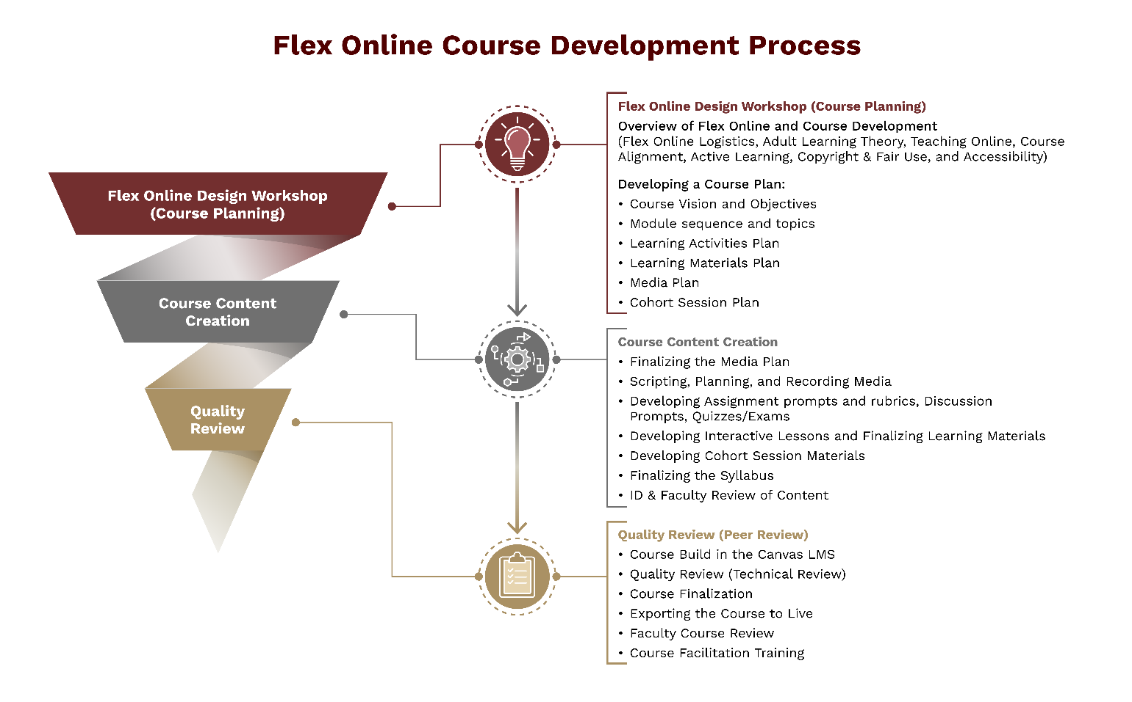
Figure 1. The three stages of the Flex Online Course Development Process

Course Maintenance
To ensure course materials remain current and relevant, the TLI Leadership Team collaborates to collect student and faculty feedback and develop a course maintenance plan to support redesigning the course every 3 years. When courses are redesigned, the SME and an ID will follow a similar Flex Online Course Development Process to guarantee a quality course redesign.

Supporting Resources
- Bowen, R.S. (2017). Understanding By Design. Vanderbilt University Center for Teaching.
- CAST. (2024, July 30). The UDL Guidelines.
- Mays Teaching & Learning Innovation. (2026). Active Learning.
- Mays Teaching & Learning Innovation. (2026). Accessibility.
- McTighe, J. and Wiggins, G. (2012). Understanding by Design Framework. ASCD.
- Quinn, J. (2021, February). About Backward Design [Video]. YouTube.

